

**Cloud Computing**

**ASSIGNMENT-1**



**Name: Subhapreet Patro**

**Roll NO.: 2211CS010547**

**Group: 3**

**Q1) Explain AWS and Azure**

**A)**

**Introduction to AWS (Amazon Web Services)**

**What is AWS?**  
AWS, or Amazon Web Services, is a cloud computing platform provided by Amazon. It leverages distributed IT infrastructure to deliver on-demand IT resources. AWS offers a range of services, including:

* **Infrastructure as a Service (IaaS)**
* **Platform as a Service (PaaS)**
* **Software as a Service (SaaS)**

AWS enables organizations to use reliable, scalable, and flexible IT infrastructure without the need for upfront investments or long-term commitments.

**Use Cases of AWS**

* **Small Businesses:** Small manufacturing companies can focus on core operations while AWS handles their IT management.
* **Global Enterprises:** Large organizations can use AWS to train their globally distributed workforce.
* **Consultants:** Architecture consulting firms can leverage AWS for high-performance rendering of construction prototypes.
* **Media Companies:** AWS can distribute digital content like eBooks and audio files to a global audience.

**Key Features of AWS**

**Pay-As-You-Go Model**

AWS charges customers based on usage, eliminating the need for upfront investment or long-term commitments.

**Core Services**

AWS provides a comprehensive set of services, including:

* **Computing**
* **Programming Models**
* **Database Storage**
* **Networking**

**Advantages of AWS**

1. **Flexibility:**
   * Allows seamless hosting of legacy applications.
   * Supports hybrid infrastructures, enabling a mix of on-premise and cloud operations.
   * Reduces the time required for core business tasks with quick deployment of new features.
2. **Cost-Effectiveness:**
   * No upfront investment is needed, significantly reducing IT costs compared to traditional infrastructure.
3. **Scalability and Elasticity:**
   * Autoscaling and load balancing handle unpredictable or high workloads, leading to cost savings and improved user satisfaction.
4. **Security:**
   * Provides end-to-end data security, privacy, and robust physical security measures.
   * Ensures confidentiality, integrity, and availability of user data.

**Introduction to Microsoft Azure**

**What is Microsoft Azure?**  
Launched in 2010, Microsoft Azure is a cloud computing platform by Microsoft. It offers a wide range of services, including cloud storage, compute resources, networking, analytics, databases, and IoT. Azure simplifies application development, deployment, and management.

Azure operates on a **Pay-As-You-Go** pricing model, ensuring cost-effectiveness and scalability.

**How Does Azure Work?**

Azure is built on virtualization technology, which separates hardware from the operating system using a **hypervisor**. The hypervisor enables multiple virtual machines (VMs) to run on a single server, each capable of operating independently.

Microsoft replicates this virtualization technique across its data centers, which house racks of servers connected via a high-speed network.

**Types of Azure Services**

1. **Infrastructure as a Service (IaaS):**
   * Includes virtual machines, storage, and networking.
   * Supports various operating systems via virtualization.
2. **Platform as a Service (PaaS):**
   * Services like Azure App Service, Azure Functions, and Logic Apps offer pre-configured environments with autoscaling and load balancing.
3. **Software as a Service (SaaS):**
   * Applications like Office 365, Dynamics 365, and Azure Active Directory are fully managed by Azure, including deployment and scaling.

**Key Characteristics of Public Cloud**

* **Accessibility:** Resources are available over the internet from anywhere.
* **Scalability:** Adjust resources based on demand.
* **Cost-Effectiveness:** Operates on a pay-as-you-go model.
* **Security:** Employs robust encryption, access controls, and compliance standards.

**Use Cases of Microsoft Azure**

1. **Application Deployment:** Deploy apps using Azure App Service and Azure Functions.
2. **Identity Management:** Secure apps and data with tools like single sign-on and multi-factor authentication.
3. **Data Storage:** Supports services like Blob Storage, Azure SQL Database, and Table Storage.
4. **DevOps:** Provides tools for version control, CI/CD, and application monitoring.
5. **Disaster Recovery and Backup:**
   * **Azure Site Recovery:** Replicate VMs to Azure and failover during disasters.
   * **Azure Backup:** Protect cloud data from deletion, ransomware, and corruption.

**Azure Competitors**

1. **Amazon Web Services (AWS):** Market leader with a broad range of cloud services.
2. **Google Cloud Platform (GCP):** Focused on data analytics and AI/ML innovations.
3. **IBM Cloud:** Offers enterprise-grade solutions, including AI and blockchain.
4. **Oracle Cloud Infrastructure (OCI):** Specializes in enterprise software and database solutions.

Both AWS and Microsoft Azure are among the top cloud service providers, catering to diverse organizational needs with unique features and competitive pricing models.

**Q2) Key components of AWS and Azure**

**A)**

**AWS (Amazon Web Services)**

AWS organizes its services around the concept of **Regions** and **Availability Zones**.

* **Regions:** These are geographically distinct locations around the world where AWS has data centers. Examples include US East (N. Virginia), EU (Ireland), and Asia Pacific (Tokyo). Each region is completely independent.
* **Availability Zones (AZs):** Within each region, there are multiple Availability Zones. These are distinct physical locations with independent power, cooling, and networking. AZs are designed to be isolated from each other, so a failure in one AZ won't affect others within the same region. This provides high availability and fault tolerance.

**Key AWS Components:**

1. **Compute:**
   * **EC2 (Elastic Compute Cloud):** The foundation of AWS compute. Provides virtual servers (instances) with various operating systems, CPU, memory, and storage options.
   * **Lambda:** Serverless computing that lets you run code without managing servers. You only pay for compute time consumed.
   * **Containers:**
     + **ECS (Elastic Container Service):** Manages Docker containers.
     + **EKS (Elastic Kubernetes Service):** Managed Kubernetes service for container orchestration.
2. **Storage:**
   * **S3 (Simple Storage Service):** Object storage for storing any type of data (images, videos, backups, etc.). Highly scalable and durable.
   * **EBS (Elastic Block Storage):** Block storage volumes that can be attached to EC2 instances. Provides persistent storage for operating systems and applications.
   * **Glacier:** Low-cost archival storage for long-term data retention.
3. **Databases:**
   * **RDS (Relational Database Service):** Supports various relational database engines like MySQL, PostgreSQL, Oracle, SQL Server, and Amazon Aurora (AWS's own high-performance database).
   * **DynamoDB:** A NoSQL database service for high-performance applications that require low latency.
4. **Networking:**
   * **VPC (Virtual Private Cloud):** Allows you to create isolated networks within the AWS cloud, giving you control over IP addresses, subnets, and network gateways.
   * **Route 53:** A scalable DNS web service for routing internet traffic to your applications.
5. **Management and Governance:**
   * **CloudFormation:** Infrastructure as code (IaC) service for defining and managing AWS infrastructure.
   * **CloudWatch:** Monitoring and observability service for collecting and tracking metrics, logs, and events.
   * **IAM (Identity and Access Management):** Controls user access to AWS resources.

**Azure (Microsoft Azure)**

Azure's core organizational unit is the **Region**, similar to AWS. Within regions, Azure uses **Availability Zones** and **Paired Regions** for high availability.

* **Regions:** Geographic areas containing Azure data centers. Examples include East US, West Europe, and Southeast Asia.
* **Availability Zones:** Physically separate data centers within an Azure region, providing fault tolerance.
* **Paired Regions:** Each Azure region is paired with another region within the same geography. This is for disaster recovery and business continuity purposes.

**Key Azure Components:**

1. **Compute:**
   * **Virtual Machines:** Provides virtual machines with various operating systems and configurations.
   * **Azure Functions:** Serverless compute service for running code on demand.
   * **Containers:**
     + **Azure Kubernetes Service (AKS):** Managed Kubernetes service for container orchestration.
     + **Azure Container Instances (ACI):** Serverless container offering for running containers without managing VMs.
2. **Storage:**
   * **Blob Storage:** Object storage for unstructured data.
   * **File Storage:** Fully managed file shares in the cloud, accessible via SMB protocol.
   * **Disk Storage:** Block storage for Azure Virtual Machines.
3. **Databases:**
   * **Azure SQL Database:** A fully managed relational database service based on SQL Server.
   * **Cosmos DB:** A globally distributed, multi-model database service supporting various data models (NoSQL).
4. **Networking:**
   * **Virtual Network:** Allows you to create isolated networks in Azure.
   * **Azure DNS:** A DNS service for managing domain names.
5. **Management and Governance:**
   * **Azure Resource Manager:** The deployment and management service for Azure. Uses declarative templates to define infrastructure as code.
   * **Azure Monitor:** Monitoring and observability service.
   * **Azure Active Directory (Azure AD):** Cloud-based identity and access management service.

**Key Differences in Organization:**

* **Focus on Regions:** Both AWS and Azure emphasize regions as the primary unit of organization.
* **Availability Zones:** Both use AZs for high availability within regions.
* **Paired Regions (Azure):** Azure has the concept of paired regions for disaster recovery, which is a more defined approach compared to AWS.
* **Resource Groups (Azure):** Azure uses Resource Groups to organize resources into logical groups for management and billing. AWS uses tags for similar purposes.

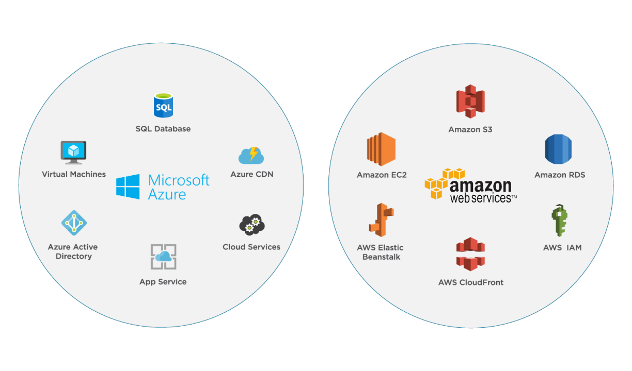

**Q3) What is IAM user and root user?**

**A)**

**IAM User and Root User in AWS**

AWS (Amazon Web Services) uses two primary types of users to manage access and permissions within an AWS account: the **Root User** and **IAM User**. Understanding these two types is essential for securely and effectively managing resources in AWS.

**What is a Root User?**

The **Root User** is the initial user that is created when an AWS account is set up. This user has unrestricted access to all resources and services within the account. It is essentially the **account owner** and possesses **god-like powers** over the AWS account.

**Key Features of the Root User:**

1. **Full Access**: The root user has unlimited access to all AWS resources and services.
2. **Unique Identity**: Every AWS account has only one root user, created with the email address and password used during account registration.
3. **Critical Permissions**: Only the root user can perform certain account-level tasks, such as:
   * Closing the AWS account.
   * Changing account settings or the support plan.
   * Activating IAM access to billing.
   * Enabling MFA delete for S3 buckets.
4. **Unrestricted Permissions**: IAM policies cannot restrict the root user's permissions. The only way to limit its access is through **Service Control Policies** in AWS Organizations.
5. **Security Best Practices**:
   * The root user should not be used for everyday tasks.
   * Enable multi-factor authentication (MFA) for additional security.
   * Use the root user only for account-specific administrative tasks.

**What is an IAM User?**

An **IAM User** (Identity and Access Management User) is a user created within an AWS account. Unlike the root user, IAM users are designed for daily operations and allow fine-grained control over access permissions.

**Key Features of IAM Users:**

1. **Limited Access by Default**:
   * By default, IAM users have no permissions. Access is granted explicitly using policies.
   * Permissions can be assigned individually or as part of a group.
2. **Customizable Permissions**:
   * Policies can be used to specify what an IAM user is allowed to do. For example, an IAM user can have full access to Amazon S3 but no permissions for Amazon EC2.
   * Follows the **principle of least privilege**, allowing users to have only the permissions necessary for their role.
3. **Multi-Purpose**:
   * IAM users can represent individuals, systems, or applications that need access to AWS resources.
4. **Authentication and Login**:
   * IAM users log in using a username, password, and the AWS account ID or alias.
   * They can also use access keys for programmatic access.
5. **Security Best Practices**:
   * Enable MFA for all IAM users.
   * Use strong password policies.
   * Avoid sharing IAM user credentials.

**Differences Between Root User and IAM User**

|  |  |  |
| --- | --- | --- |
| **Aspect** | **Root User** | **IAM User** |
| **Creation** | Automatically created when the AWS account is set up. | Created by the root user or another IAM user with sufficient permissions. |
| **Access** | Full access to all AWS resources without any restrictions. | Access is limited by explicitly assigned permissions. |
| **Number of Users** | Only one root user per AWS account. | Multiple IAM users can be created as needed. |
| **Critical Tasks** | Can perform account-specific tasks like closing the account, managing billing, and MFA delete. | Cannot perform certain account-specific tasks (e.g., closing the account). |
| **Restricting Permissions** | Cannot be restricted by IAM policies; only limited by Service Control Policies. | Permissions are explicitly assigned using IAM policies. |
| **Use Case** | Reserved for rare, account-level administrative tasks. | Used for day-to-day operational tasks or application-level access. |

**Best Practices for Using Root and IAM Users**

1. **Limit Root User Usage**: Use the root user sparingly and only for critical tasks.
2. **Enable MFA**: Ensure MFA is enabled for both root and IAM users.
3. **Avoid Sharing Credentials**: Never share credentials for root or IAM users.
4. **Create Administrator IAM User**: Immediately create an administrator IAM user after setting up the AWS account and use it for administrative tasks.
5. **Follow Least Privilege Principle**: Assign only the necessary permissions to IAM users.

**Q4) Explain instance in AWS and explain its types**

**A)**

**What is an Instance in AWS?**

An **instance** in AWS refers to a virtual server within the Amazon Elastic Compute Cloud (**EC2**) service. Instances are fundamental components of AWS cloud computing, providing scalable compute capacity for running applications, services, and workloads. AWS EC2 instances allow users to rent virtualized computing resources on-demand, with varying configurations of CPU, memory, storage, and networking.

AWS EC2 offers a range of instance types optimized for different use cases to cater to the specific needs of applications. The selection of an instance type depends on the workload, resource requirements, and cost considerations.

**Types of AWS EC2 Instances**

AWS EC2 instances are categorized into five primary types, each tailored to specific workloads:

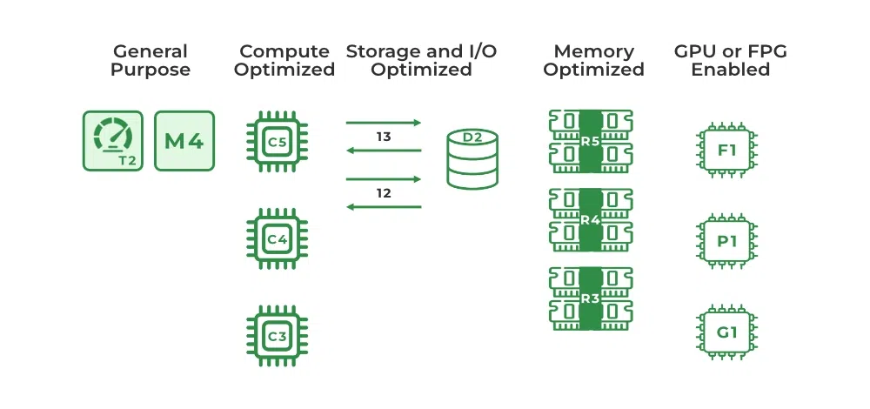

**1. General-Purpose Instances**

These instances provide a balanced ratio of compute, memory, and networking resources. They are versatile and suitable for a wide range of applications that do not require optimisation in a specific resource area.

**Examples:**

* Gaming servers
* Small databases
* Development and testing environments
* Web servers and content delivery

**Features:**

* Optimized by default with Elastic Block Store (EBS).
* Powered by AWS Graviton3 processors.
* Flexible configurations for varying CPU and memory needs.

**Instance Types:**

* **T2.micro**: 1 CPU, 1 GB memory, free tier-eligible, low to moderate network performance.
* **M6a.large**: 2 CPUs, 8 GiB memory, network performance up to 12.5 Gbps.
* **M5.large**: Intel Xeon Platinum processors, high bandwidth, and lightweight hypervisors.

**2. Compute-Optimized Instances**

Designed for compute-intensive workloads requiring high-performance CPUs. These instances are ideal for applications that demand fast processing and low latency.

**Examples:**

* High-performance web servers
* Gaming servers
* Batch processing workloads
* Machine learning model training

**Features:**

* Powered by AWS Graviton3 processors.
* DDR5 memory with 50% more bandwidth than DDR4.
* Optimized for applications requiring high CPU-to-memory ratios.

**Instance Types:**

* **C5d.24xlarge**: 96 CPUs, 192 GiB RAM, 3600 GB SSD, 12 Gbps network performance.

**3. Memory-Optimized Instances**

Optimized for workloads that require processing large datasets in memory. These instances are suited for tasks with significant memory requirements and real-time processing.

**Examples:**

* In-memory databases like Redis or Memcached
* Big data analytics (Apache Spark, Hadoop)
* Real-time data processing

**Features:**

* Elastic Fabric Adapter (EFA) support for high-performance networking.
* Uses the latest DDR5 memory with higher bandwidth.
* Enhanced networking with improved bandwidth.

**Instance Types:**

* **R7g.medium**: 1 CPU, 8 GiB memory, EBS storage, up to 12.5% network bandwidth.
* **X1**: 64 vCPUs, 976 GiB memory, high bandwidth for enterprise databases.

**4. Storage-Optimized Instances**

Built for workloads that require fast and sequential read/write access to large datasets. These instances are tailored for data-intensive applications with high input/output requirements.

**Examples:**

* Distributed file systems
* Data warehousing
* High-frequency OLTP systems

**Features:**

* Uses AWS Graviton2 processors for price/performance optimization.
* Provides up to 100 Gbps network bandwidth.
* Designed for high throughput and low latency.

**Instance Types:**

* **Im4gn.large**: 2 CPUs, 8 GiB memory, EBS storage, up to 25 Gbps network bandwidth.
* **I3**: High local NVMe storage for intensive workloads.

**5. Accelerated Computing Instances**

Accelerated instances use hardware accelerators like GPUs or FPGAs to perform specific tasks more efficiently than CPUs. They are ideal for applications requiring complex calculations or graphics processing.

**Examples:**

* Floating-point calculations
* Graphics rendering and game streaming
* Machine learning and data pattern matching

**Features:**

* Equipped with NVIDIA GPUs for high-performance computing.
* Enhanced support for NVIDIA GPUDirect RDMA.
* Elastic Fabric Adapter for high-speed networking.

**Instance Types:**

* **P4**: 8 NVIDIA A100 GPUs, 96 CPUs, 1152 GiB memory, 400 Gbps instance networking.
* **G4 Instances**: Optimized for graphical workloads, offering up to 65 teraflops of performance.

**AWS EC2 Instance Pricing Models**

AWS provides flexible pricing models for instances:

1. **On-Demand Instances**: Pay for usage by the hour or second without long-term commitments. Ideal for testing or unpredictable workloads.
2. **Savings Plans**: Commit to a term (1-3 years) for reduced rates compared to On-Demand instances. Suitable for consistent usage patterns.
3. **Spot Instances**: Utilize unused EC2 capacity at discounts of up to 90%. Best for flexible workloads with interruptible requirements.

**AWS Pricing Calculator**

AWS offers an AWS Pricing Calculator to estimate costs for selected instance types. Users can configure and visualize costs in both graphical and documented formats.

**Q5) Explain AMI**

**A)**

**Explanation of Amazon Machine Image (AMI)**

**What is an AMI?**  
An Amazon Machine Image (AMI) is a master template used for creating virtual servers, known as Amazon EC2 instances, in the Amazon Web Services (AWS) environment. It provides a pre-configured operating system and software setup, enabling users to quickly and efficiently launch virtual servers with a consistent environment.

**Components of an AMI**

1. **Template for Root Volume:**
   * Includes the operating system (e.g., Linux, Windows) and additional software, such as application servers or applications, that define the operating environment.
   * Ensures that all EC2 instances launched from this AMI have the same configuration.
2. **Permissions:**
   * Controls access to ensure that only authorized AWS accounts can launch instances using the AMI. Permissions can be set to private, shared with specific accounts, or public.
3. **Block Device Mapping:**
   * Defines the storage volumes attached to the instance when it is launched, ensuring the appropriate storage configuration.

**AMI Types and Attributes**  
AMIs are categorized based on several factors:

1. **Region:**
   * AMIs are region-specific, meaning they are available within particular AWS regions but can be copied to other regions as needed.
2. **Operating System:**
   * The AMI's OS can range from Linux distributions (e.g., Amazon Linux, Ubuntu) to Windows Server.
3. **Architecture:**
   * Specifies whether the AMI supports 32-bit or 64-bit systems, depending on the underlying hardware requirements.
4. **Launch Permissions:**
   * AMIs can be public (accessible to all AWS users), shared with specific accounts, or private (accessible only to the owner).
5. **Root Device Storage:**
   * AMIs are backed by either:
     + **Amazon Elastic Block Store (EBS):** Persistent storage volumes that can be detached and re-attached to other instances.
     + **Instance Store:** Temporary storage that persists only during the lifetime of the instance.

**Virtualization Types**  
AWS supports two virtualization types for AMIs:

1. **Paravirtualization (PV):**
   * Offers improved performance by eliminating the overhead of hardware emulation.
   * Requires a modified guest operating system kernel.
   * Suitable for high-performance computing applications.
2. **Hardware Virtual Machines (HVM):**
   * Fully virtualized environments where hardware emulation is necessary.
   * Requires specific hardware features like virtualization extensions (e.g., Intel VT-x).
   * Can run unmodified guest operating systems.

**Creating an AMI**

1. Open the **Amazon EC2 instances view**.
2. Right-click on an existing running or stopped instance and select **Create Image**.
3. Fill out the required fields, such as the name and description.
4. AWS shuts down the instance (unless "No Reboot" is selected), takes snapshots of attached volumes, and creates the AMI.
5. The AMI appears in the **AMIs view** under the user's account.

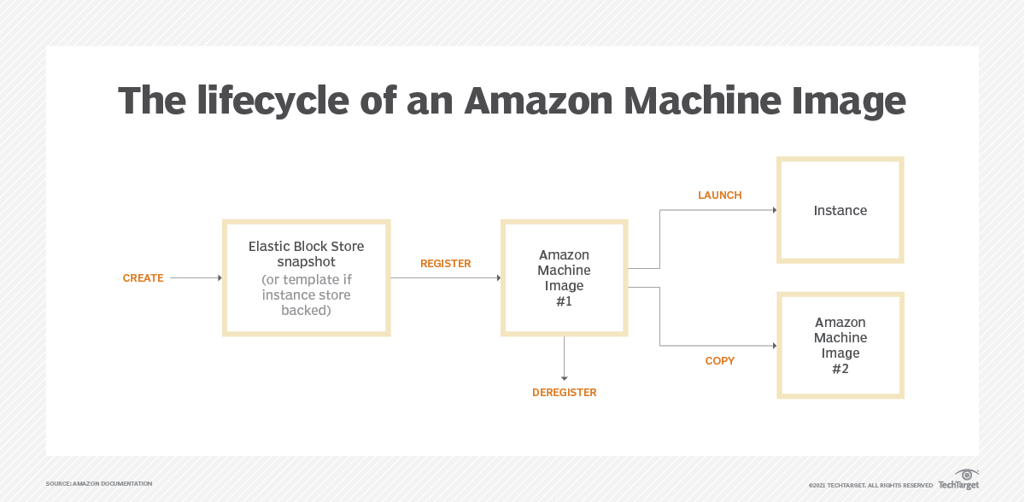

**Lifecycle and Usage**

1. **Searching for an AMI:**
   * AMIs can be searched by region, operating system, architecture, and launch permissions. Users can select AMIs provided by AWS, the community, or through the AWS Command Line Interface (CLI).
2. **Copying an AMI:**
   * AMIs can be copied to the same or other AWS regions for flexibility and disaster recovery.
3. **Using an AMI:**
   * Once registered, AMIs are used to launch EC2 instances. Instances can also be launched from shared or public AMIs, provided permissions are in place.
4. **Deregistering an AMI:**
   * An AMI can be deregistered when it is no longer needed. This action does not affect running instances but prevents new instances from being launched from the AMI.

**Buying and Selling AMIs**

* **Shared AMIs:** Users can share AMIs publicly or with specific accounts, but caution is advised as AWS does not guarantee the integrity of shared AMIs.
* **Third-party AMIs:** AMIs with service contracts (e.g., from Red Hat) can be purchased for specific use cases.
* **Selling AMIs:** Users can monetize their custom AMIs by selling them to other AWS customers.

**Key Benefits of AMIs**

* **Consistency:** Ensures all EC2 instances launched from the same AMI have identical configurations.
* **Flexibility:** AMIs can be customized, shared, and copied across regions.
* **Scalability:** Simplifies deploying multiple instances with the same configuration in various environments.

By providing a reliable and reusable template, AMIs streamline server deployment in the AWS cloud environment.

**Q6) Explain S3**

**A)**

Amazon S3 (Simple Storage Service) is a scalable, high-performance, and secure object storage service provided by Amazon Web Services (AWS). It is widely used for storing and managing data on the cloud. Here's a detailed explanation of its key features and components:

**1. What is Amazon S3?**

Amazon S3 provides object storage for storing files like photos, videos, documents, and more. It is designed for scalability, high availability, and security, enabling users to store and retrieve any amount of data from anywhere.

* **Scalability**: Handles small to large-scale data storage needs.
* **High Durability:** 99.999999999% (11 nines) durability ensures data is rarely lost.
* **High Availability**: 99.99% uptime, ensuring reliable data access.
* **Integration**: Seamlessly integrates with other AWS services.

**2. Key Concepts**

**Buckets and Objects**

* **Buckets**: Containers in which data (objects) are stored. Each bucket name must be globally unique and can be configured with specific access controls.
* **Objects**: Individual data units stored in S3, identified by a unique key within a bucket.

**Versioning**

* Keeps all versions of objects in a bucket to prevent accidental deletions or overwrites.
* Once enabled, versioning applies to all objects in the bucket.

**Lifecycle Policies**

* Automates the movement of data between storage classes or schedules data deletion to reduce costs.

**Access Control**

* Managed through Bucket Policies, Access Control Lists (ACLs), and IAM Policies to control who can access data and how.

**Encryption**

* Supports Server-Side Encryption (SSE) with different models:
  + **SSE-S3**: AWS-managed encryption keys.
  + **SSE-C**: Customer-managed encryption keys.
  + **SSE-KMS**: AWS Key Management Service for key management.

**3. Types of S3 Storage Classes**

Amazon S3 offers different storage classes tailored to specific use cases:

1. **Standard**: For frequently accessed data.
2. **Standard-IA**: Infrequently accessed data; lower storage cost but retrieval fees apply.
3. **Intelligent Tiering**: Automatically moves data between access tiers based on usage.
4. **One Zone-IA**: Stores data in a single availability zone, suitable for non-critical, infrequently accessed data.
5. **Glacier**: Optimized for long-term archival with retrieval times ranging from minutes to hours.

**4. Features of Amazon S3**

* **Infinite Storage**: Can theoretically store an unlimited amount of data.
* **Durability and Availability**: Data replication across multiple availability zones ensures reliability.
* **Pay-as-you-go Pricing**: Costs are based on storage usage, retrieval, and data transfer.
* **Data Lifecycle Management**: Automates data transitions to cost-effective storage classes.
* **Event Notifications**: Triggers AWS services like Lambda when certain actions occur in the bucket.
* **Integration**: Easily integrates with services like AWS Lambda, Amazon CloudFront, and Amazon Redshift.

**5. Use Cases of Amazon S3**

1. **Data Storage**: Scalable storage for both small and large applications.
2. **Backup and Recovery**: Reliable solution for storing critical backups with fast recovery options.
3. **Hosting Static Websites**: Cost-effective hosting of static content like HTML, CSS, and JavaScript files.
4. **Big Data Analytics**: Acts as a data lake for storing and processing large datasets.
5. **Archival**: S3 Glacier provides a low-cost solution for long-term data storage.

**6. How Does Amazon S3 Work?**

Amazon S3 operates on a straightforward model:

1. Create a **bucket**.
2. Upload objects to the bucket.
3. Manage access to the bucket using policies or permissions.
4. Organize data using keys (file paths) and manage lifecycle policies.
5. Retrieve or modify data through the AWS Management Console, AWS CLI, or SDKs like Boto3 for Python.

**7. Advantages of Amazon S3**

* **High Scalability**: Automatically adjusts to growing storage needs.
* **Cost-Effective**: Multiple storage classes tailored to access patterns and cost requirements.
* **Easy Integration**: Works seamlessly with other AWS services.
* **Secure**: Offers encryption, IAM roles, and fine-grained access controls.
* **Global Reach**: Data can be accessed from anywhere with low-latency performance.

**8. Accessing Amazon S3**

You can access S3 in multiple ways:

1. **AWS Management Console**: User-friendly interface for managing buckets and objects.
2. **AWS CLI**: Command-line tool for advanced operations.
3. **SDKs (e.g., Boto3 for Python)**: Allows programmatic interaction with S3 buckets.

**9. Common Operations**

1. **Uploading Files**: aws s3 cp <local-file-path> s3://<bucket-name>/
2. **Listing Buckets**: aws s3 ls
3. **Managing Permissions**: Using Bucket Policies, ACLs, or IAM Policies.

**Q7) Relationship between an instance and AMI**

**A)**

The relationship between an **Amazon EC2 Instance** and an **Amazon Machine Image (AMI)** is fundamental to how instances are launched and operate in AWS. Here's a detailed explanation:

**What is an AMI?**

* **AMI (Amazon Machine Image)** is a template that defines the configuration of an EC2 instance. It includes:
  1. **Operating System (OS)**: For example, Linux, Windows, or Ubuntu.
  2. **Application Stack**: Pre-installed software (e.g., LAMP stack or custom apps).
  3. **System Settings**: Includes OS-level configurations, network configurations, and more.
  4. **EBS Snapshots**: If the instance uses Elastic Block Store (EBS) for storage, AMI includes snapshots of those volumes.
  5. **Permissions**: Determines who can use the AMI to launch instances.

**What is an EC2 Instance?**

* An **EC2 instance** is a virtual server in the cloud, created when you launch an AMI. The instance is a running state of the machine defined by the AMI, which operates on AWS's compute infrastructure.

**Relationship Between AMI and Instance**

1. **AMI is the Blueprint, Instance is the Result**
   * An AMI serves as the **blueprint** or template for creating an EC2 instance.
   * When you launch an instance, AWS uses the AMI to configure the instance with the specified OS, software, and settings.
2. **Multiple Instances from One AMI**
   * You can launch multiple instances from a single AMI. Each instance will have identical initial configurations based on the AMI, but can be customized further post-launch.
3. **Custom AMIs from Instances**
   * After configuring an EC2 instance (e.g., installing custom software or making OS-level changes), you can create a custom AMI from that instance.
   * This new AMI can then be used to launch other instances with the same customizations.
4. **Immutable AMIs**
   * The AMI itself is immutable; once created, it doesn’t change. However, the instances launched from it can be modified.
5. **Shared AMIs**
   * AMIs can be shared across AWS accounts or even made public, allowing other users to launch instances using that AMI.

**Lifecycle: From AMI to Instance**

1. **Select/Create an AMI**
   * Choose a pre-existing AMI from AWS Marketplace or the public catalog.
   * Or create a custom AMI from an existing EC2 instance.
2. **Launch EC2 Instance**
   * Select the AMI during the instance creation process.
   * Configure instance parameters (e.g., instance type, security groups, networking).
3. **Run Instance**
   * The EC2 instance runs based on the configuration in the AMI.
   * You can interact with the instance to install software, change settings, etc.
4. **Optionally Create New AMI**
   * After modifying the instance, you can create a new AMI from it for reuse.

**Key Points**

* **Dependency**: Instances are always launched from an AMI. Without an AMI, you cannot create an EC2 instance.
* **Scalability**: AMIs allow you to scale by launching multiple instances with the same configuration.
* **Customization**: Custom AMIs let you replicate and deploy pre-configured environments efficiently.
* **Reusability**: AMIs ensure consistency in launching identical instances.

**Q8) Difference between Amazon S3 and EC2**

**A)**

**Key Differences Between Amazon EC2 and Amazon S3 in AWS**

Amazon EC2 (Elastic Compute Cloud) and Amazon S3 (Simple Storage Service) are two essential services provided by Amazon Web Services (AWS). While both are foundational to cloud computing, they serve distinct purposes and are designed for different use cases.

**Amazon EC2: Compute in the Cloud**

**Purpose:**  
Amazon EC2 is a cloud computing service that provides scalable and resizable compute capacity. It allows users to run virtual servers, known as instances, on-demand in the cloud.

**Use Cases:**

* Running applications, including web servers and enterprise software.
* Hosting websites or web applications.
* Processing large datasets and running compute-intensive tasks.

**Key Features:**

* **Flexible Instance Types:** Choose from various instance types optimized for specific workloads, such as compute-optimized or memory-optimized.
* **Auto-Scaling:** Automatically adjust compute capacity based on demand.
* **Load Balancing:** Distribute traffic efficiently across instances for high availability.
* **Customizable Networking:** Configure virtual private clouds (VPCs) and security groups for networking and security.

**Amazon S3: Object Storage for Any Data**

**Purpose:**  
Amazon S3 is an object storage service designed to store and retrieve any amount of data, anywhere on the web. It excels in storing files, data objects, and other unstructured data.

**Use Cases:**

* Backup and restore solutions for critical data.
* Data archiving with minimal maintenance.
* Hosting and serving static website content.
* Storing large datasets for analytics and big data processing.

**Key Features:**

* **High Durability and Availability:** S3 ensures data reliability with multiple copies stored across multiple availability zones.
* **Versioning:** Keep track of changes and retain previous versions of objects.
* **Lifecycle Policies:** Automate data management by transitioning or deleting objects based on their lifecycle stage.
* **Access Controls:** Secure data using fine-grained permissions and encryption options.

Here’s a tabular comparison of Amazon EC2 and Amazon S3:

|  |  |  |
| --- | --- | --- |
| **Feature** | **Amazon EC2** | **Amazon S3** |
| **Purpose** | Provides resizable compute capacity (virtual servers) for running applications. | Object storage service for storing and retrieving data. |
| **Primary Use** | Running applications, web hosting, data processing, compute tasks. | Storing files, backups, static website content, and data archiving. |
| **Resource Type** | Virtual servers (instances) with configurable CPU, memory, and storage. | Object storage for data (files, images, videos, etc.). |
| **Scalability** | Scalable compute resources (up or down based on demand). | Scalable storage with virtually unlimited capacity. |
| **Key Features** | Flexible instance types, auto-scaling, load balancing, customizable networking. | High durability, versioning, lifecycle policies, access controls. |
| **Data Storage** | Temporary or persistent storage attached to instances (e.g., EBS volumes). | Persistent object storage with 99.999999999% durability. |
| **Networking** | Customizable virtual networks (VPC), security groups, and load balancing. | No direct networking, but objects can be accessed globally via URLs. |
| **Billing** | Pay-per-use based on compute time (hourly or per-second). | Pay-per-use based on storage amount and data transfer. |
| **Best Use Case** | Running compute-intensive tasks, hosting dynamic applications, batch processing. | Storing large volumes of unstructured data, backups, media files, static website content. |
| **Access Type** | Access via SSH (Linux) or RDP (Windows) for instance management. | Access via HTTP/HTTPS or SDKs for uploading/downloading objects. |

Both Amazon EC2 and Amazon S3 are integral to building and managing applications in the cloud. EC2 is focused on **computational tasks**, while S3 provides **reliable storage** for any type of data.

**Q9) What are key-pairs in AWS?**

**A)**

In Amazon Web Services (AWS), **key pairs** are a fundamental security feature used for secure login to EC2 instances. A key pair consists of a **public key** and a **private key**. The public key is stored on the EC2 instance, while the private key is kept securely by the user. This key pair is used for SSH (Secure Shell) access to Linux/Unix-based EC2 instances and RDP (Remote Desktop Protocol) for Windows instances.

**Key Components of AWS Key Pairs:**

1. **Public Key:**
   * The public key is stored on the EC2 instance when it is launched.
   * It is not sensitive and is used by AWS to encrypt the login information.
   * When a user attempts to connect to an EC2 instance using SSH or RDP, the public key is used to verify that the user has the corresponding private key.
2. **Private Key:**
   * The private key is securely stored by the user, either on their local machine or within a secure key management system.
   * The private key should never be shared, as it is the "secret" that grants access to the instance.
   * It is used to decrypt the information that is encrypted by the public key.

**How Key Pairs Work:**

1. **Creation:**
   * When you launch an EC2 instance, AWS prompts you to either create a new key pair or use an existing one.
   * If you choose to create a new key pair, AWS generates a unique pair of keys (public and private) for you.
   * The **private key** (.pem file) is downloaded to your machine, and the **public key** is automatically embedded into the instance's configuration.
2. **Usage:**
   * For **Linux/Unix instances**, the private key is used to authenticate via SSH. When you attempt to SSH into the instance, your SSH client uses the private key to prove your identity. AWS checks the public key that was installed on the instance during launch to grant or deny access.
     + Example SSH command: ssh -i my-key-pair.pem ec2-user@<ec2-public-dns>
   * For **Windows instances**, the private key is used to obtain the RDP password (from AWS). Once you have the password, you can use it to log in via RDP.
3. **Security:**
   * The **private key** is the most critical part of the key pair and should be treated securely. If someone obtains access to the private key, they can potentially access the EC2 instances it’s associated with.
   * **Key pairs** eliminate the need for traditional password-based login methods, which enhances security by relying on cryptographic authentication rather than shared secrets.
4. **Management:**
   * Key pairs can be managed from the **AWS Management Console** or **AWS CLI**.
   * You can create, delete, or download key pairs in the **EC2 Dashboard**.
   * Once created, a key pair cannot be downloaded again from AWS for security reasons, so it’s important to securely store the private key when first created.
   * If you lose the private key, you will not be able to access the associated EC2 instance, and you may need to use other methods to regain access (e.g., using EC2 Instance Connect, or detaching the volume and attaching it to another instance).

**Key Pair Management Best Practices:**

1. **Storage:**
   * Store the private key in a secure location (e.g., in an encrypted folder, key management service, or secure vault).
   * Never share the private key with anyone, and ensure it’s not exposed in public repositories or version control systems.
2. **Access Control:**
   * Use IAM (Identity and Access Management) roles and policies to restrict who can launch EC2 instances and create or manage key pairs.
   * Ensure that only authorized users have the necessary permissions to access EC2 instances using the key pair.
3. **Regenerating Keys:**
   * If a key pair is compromised, generate a new key pair and update the EC2 instance with the new key.
   * You can also use EC2 Instance Connect or Systems Manager Session Manager to access the instance and update the authorized keys.
4. **Key Rotation:**
   * Regularly rotate key pairs for added security. For EC2 instances, you can upload new public keys and replace the old ones.
5. **Using EC2 Instance Connect (for SSH):**
   * EC2 Instance Connect allows you to connect to your instances without needing a traditional key pair. You can use it from the AWS console or via the CLI to establish temporary SSH connections, which can be useful in cases where you’ve lost your key pair.

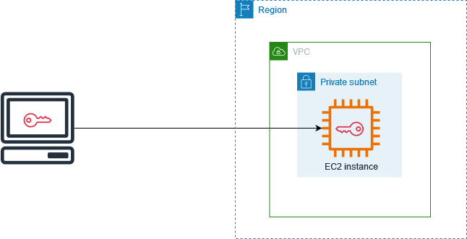

**Q10) What is an EIP?**

**A)**

**AWS Elastic IP Addresses**

An **Elastic IP (EIP)** address is a **static IPv4 address** designed for dynamic cloud computing. It provides a persistent public IP address that can be quickly associated with an EC2 instance in your AWS account. Elastic IPs are primarily used to mask the failure of instances or software by mapping the address to another running instance, allowing you to quickly recover from failure without needing to update DNS records or clients.

**Key Concepts of Elastic IP:**

* **Public IPv4 address**: Elastic IP addresses are publicly accessible like any other IPv4 address. They are associated with instances in a specific AWS region and allow communication from the internet to the EC2 instances.
* **Elastic IP's Persistence**: Unlike dynamic public IP addresses, which change when an instance is stopped or restarted, an Elastic IP remains static as long as it is allocated to your AWS account, even if the associated instance is stopped or terminated.
* **No IPv6 Support**: Elastic IP addresses currently only support IPv4 and do not support IPv6.

**Elastic Pricing for IP Addresses:**

* **Free Usage**: Elastic IP addresses are free if they are actively associated with a running EC2 instance or other AWS resource. This encourages users to release unused IP addresses.
* **Charges for Unused IPs**: If an Elastic IP address is not associated with any running instance, AWS imposes a small hourly fee of $0.005 per hour to encourage efficient use of resources.
* **Use Cases for Charges**:
  + When an Elastic IP is not associated with an EC2 instance.
  + When an instance is stopped but still holding the Elastic IP.
  + When there are more than 100 remaps of Elastic IP addresses within a month.

**Elastic IP Addresses and AWS Network Scope:**

* **Geographical Boundaries**: Elastic IP addresses are assigned based on the region in which your EC2 instance resides. For example, an EC2 instance in the **US East** region will be assigned a public IP address from that region's available pool.
* **Region-Scoped IPs**: AWS limits the number of Elastic IP addresses per region to **five** by default. If more are needed, you must request a higher limit.
* **Private IP Usage**: Private IP addresses can also be used for internal communication between instances in a region without incurring charges for traffic.

**Working of AWS Elastic IP:**

1. **Allocate Elastic IP Address**:
   * You can allocate an Elastic IP from Amazon's pool or from your own IP address pool if you've set one up.
   * For example, if you have **AWS Outposts**, you can allocate an IP address from your on-premises IP address pool.
2. **Describe and Tag Elastic IP Address**:
   * View metadata like names, descriptions, and port numbers associated with the IP in the AWS management console.
   * Use tags to manage multiple Elastic IPs efficiently.
3. **Connect or Disconnect Elastic IP**:
   * You can associate the Elastic IP with an EC2 instance or a network interface, and you can also disconnect or reassociate it as needed.
4. **Release Elastic IP Address**:
   * If no longer needed, you can release the Elastic IP address, which will free up the resource for others to use.

**Features of AWS Elastic IP:**

* **Static Address**: The Elastic IP address does not change over time, unlike dynamic public IPs.
* **Association with Network Interface**: The IP is tied to an EC2 instance’s primary network interface. When the instance is associated with the Elastic IP, it is also linked with the network interface.
* **Resiliency**: Elastic IPs help with high availability and fault tolerance. In case of failure, you can quickly remap the IP to a new instance.
* **Region-Specific**: Elastic IPs are scoped to a specific region and cannot be moved across regions.
* **No Cost if in Use**: There is no charge for using the Elastic IP as long as it is associated with a running EC2 instance.
* **Custom IP Pool**: You can bring your own IP addresses if you have a custom IP pool added to your AWS account.
* **Public DNS Update**: If you associate an Elastic IP with an instance, the public DNS hostname for that instance will reflect the new IP address.

**Limitations of Elastic IP:**

* **Limited Resources**: Public IPv4 addresses are finite, and AWS imposes a default limit of **five Elastic IP addresses per region**.
* **Costs for Unused Elastic IPs**: AWS charges for unused Elastic IP addresses, which can lead to unnecessary costs if not managed properly.
* **Region-Specific**: Elastic IPs are tied to the region where they are allocated, which means they cannot be used across regions. If you move an instance to a different region, you'll need to release the current Elastic IP and allocate a new one in the new region.
* **Resource Management**: To avoid unnecessary costs, it’s important to release unused Elastic IP addresses. Over-provisioning Elastic IPs can result in higher costs.

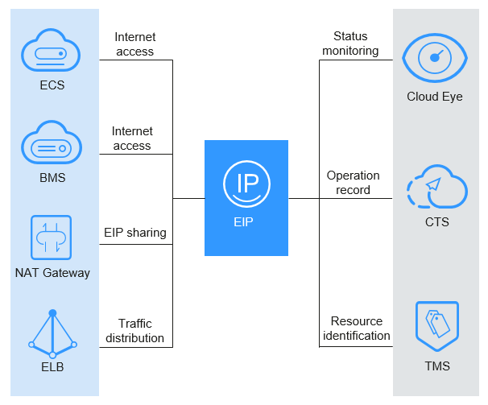

**Q11) What are the key benefits of adopting computing and how does Microsoft Azure address these benefits?**

**A)**

**Key Benefits of Adopting Cloud Computing and how Microsoft Azure addresses them:**

1. **Cost Efficiency**:
   * **Pay-as-you-go model**: Cloud computing allows businesses to only pay for the resources they use, eliminating the need for large upfront investments in hardware and infrastructure. This makes it easier to manage operating costs and scale the business more effectively.
   * **No hardware maintenance costs**: With cloud services, there is no need to maintain and manage physical servers and data centers, further reducing the overhead costs related to hardware management and maintenance.
2. **Scalability and Flexibility**:
   * Cloud computing offers businesses the flexibility to scale resources up or down based on their specific needs. Whether it’s increasing storage or processing power to handle a surge in traffic or scaling down after peak demand, cloud computing makes it easy to adapt without significant changes to the underlying infrastructure.
   * **Azure’s scalability**: Microsoft Azure addresses this benefit through its elastic infrastructure, which provides automatic scaling of resources based on workload demand. Azure's services, such as virtual machines, databases, and app services, allow businesses to easily scale resources as needed, ensuring optimal performance and cost-efficiency.
3. **Data Security and Compliance**:
   * Cloud computing platforms like Azure offer robust security features, including encryption, multi-factor authentication, and compliance certifications to ensure data protection and meet regulatory requirements. Cloud environments often include continuous monitoring, automated patching, and proactive security measures.
   * **Azure’s Security and Compliance**: Azure implements various security features such as role-based access control, built-in threat intelligence, and compliance with global standards. These features help organizations ensure that their data is secure while adhering to regulations such as GDPR, HIPAA, and others. Azure also provides encrypted data storage both at rest and in transit, offering an additional layer of protection.
4. **Business Continuity and Disaster Recovery**:
   * Cloud computing helps ensure business continuity by providing disaster recovery solutions that ensure minimal downtime during a disaster or system failure. Backups, automated failover processes, and replication across multiple geographic regions ensure data is safe and can be restored quickly in case of any issues.
   * **Azure’s Disaster Recovery**: Azure provides services such as **Azure Site Recovery** and **Azure Backup**, which allow businesses to replicate their critical applications and data to the cloud and restore them quickly in the event of an outage. These services help reduce the impact of disasters, ensuring business operations can continue seamlessly.
5. **Improved Collaboration and Productivity**:
   * Cloud computing improves collaboration by offering easy access to shared applications and data across teams, no matter their location. Cloud-based tools enable seamless real-time collaboration, document sharing, and communication, improving productivity and teamwork.
   * **Azure’s Collaboration Tools**: Azure integrates with tools like **Microsoft Teams**, **SharePoint**, and **Azure Active Directory**, which enhance collaboration and productivity within organizations. Azure Active Directory simplifies user management and security across applications, while Teams and SharePoint enable real-time collaboration on documents and projects.
6. **Advanced Analytics and Business Intelligence**:
   * Cloud platforms like Azure offer powerful analytics and business intelligence (BI) capabilities. Businesses can gain valuable insights by processing large datasets in real-time, performing advanced analytics, and leveraging machine learning models to make data-driven decisions.
   * **Azure’s Analytics Tools**: With services like **Azure Machine Learning**, **Azure Power BI**, and **Azure HDInsight**, businesses can process and analyze vast amounts of data to gain insights, forecast trends, and make more informed decisions. These tools empower businesses to tap into the full potential of their data for innovation and strategic planning.
7. **Performance and Reliability**:
   * Cloud providers offer high performance by optimizing infrastructure and ensuring that resources are always available when needed. With cloud computing, organizations benefit from high availability, minimal downtime, and optimized infrastructure performance.
   * **Azure’s Performance**: Azure ensures high availability through its global network of data centers, Availability Zones, and load balancing mechanisms. Azure services such as virtual machines, storage, and databases are designed for optimal performance, offering low latency and reliable access to critical applications and data across regions.

**How Microsoft Azure Addresses These Benefits**

1. **Cost Efficiency**:
   * **Pay-as-you-go pricing**: Azure provides businesses with a cost-efficient, pay-per-use model, allowing companies to only pay for the resources they consume, whether it’s storage, computing power, or bandwidth. This flexibility reduces capital expenditures and makes the cloud more affordable for businesses of all sizes.
   * **Azure Cost Management**: Azure offers tools like **Azure Cost Management** to monitor and optimize cloud spend. This helps businesses track their usage, set budgets, and manage costs efficiently, ensuring they don’t exceed their intended budget.
2. **Scalability and Flexibility**:
   * **Elastic Scaling**: Azure’s infrastructure offers automatic scaling for services like virtual machines and app services, allowing businesses to scale resources according to real-time demand. This ensures that businesses have enough resources during peak periods without overpaying when the demand drops.
   * **Azure Hybrid Capabilities**: Azure enables businesses to integrate on-premises infrastructure with cloud resources through tools like **Azure Stack** and **Azure Arc**. These hybrid capabilities allow organizations to manage both on-premises and cloud workloads seamlessly, offering more flexibility in how they deploy and manage applications.
3. **Data Security and Compliance**:
   * **Advanced Security Features**: Azure’s built-in security services, including **Azure Security Center** and **Azure Active Directory**, provide comprehensive security management, real-time threat detection, and identity protection. These features help businesses safeguard their data from potential breaches and unauthorized access.
   * **Compliance**: Azure provides compliance with major international standards such as ISO 27001, GDPR, HIPAA, and more. It offers automated tools to help businesses meet these compliance requirements without extensive manual effort.
4. **Business Continuity and Disaster Recovery**:
   * **Azure Site Recovery**: Azure’s **Site Recovery** allows businesses to replicate workloads to the cloud and seamlessly failover in the event of a disaster. This ensures minimal downtime and business continuity by enabling quick recovery of critical applications and data.
   * **Azure Backup**: Azure Backup offers automated cloud-based backup solutions for data and applications, ensuring that business-critical information is securely stored and easily recoverable.
5. **Improved Collaboration and Productivity**:
   * **Integrated Collaboration Tools**: Azure integrates with Microsoft’s productivity suite, including **Microsoft Teams**, **Office 365**, and **SharePoint**, enabling teams to collaborate efficiently on documents, communicate in real-time, and streamline workflows.
   * **Azure Active Directory**: Azure AD simplifies user management by providing centralized access control for cloud applications, improving security and making it easier for businesses to manage users and their permissions.
6. **Advanced Analytics and Business Intelligence**:
   * **Azure Machine Learning**: Azure allows businesses to build, train, and deploy machine learning models to extract valuable insights from data. This helps businesses uncover patterns, make predictions, and automate processes for greater efficiency.
   * **Azure Power BI**: Azure integrates with Power BI to provide business intelligence capabilities, enabling businesses to analyze data visually and make data-driven decisions. Power BI integrates seamlessly with other Azure services, enabling a complete data analytics workflow.
7. **Performance and Reliability**:
   * **Global Network of Data Centers**: Azure operates a large network of data centers across the globe, ensuring high availability and low latency for applications and services. Businesses can take advantage of Azure’s multiple Availability Zones to ensure that their applications remain highly available and performant.
   * **Load Balancing and Redundancy**: Azure offers advanced load balancing and redundancy options, allowing businesses to distribute workloads effectively and avoid performance bottlenecks. This ensures optimal application performance even under heavy usage.

**Q12) Explain the role of the Azure Resource Manager (AZM) in managing resources in Azure.**

**A)**

Azure Resource Manager (ARM) plays a critical role in managing resources within Microsoft Azure by acting as the control plane for organizing and administering resources in the cloud. Its primary responsibility is to manage the deployment, updating, and deletion of Azure resources. Below are the key aspects of how ARM facilitates resource management in Azure:

**1. Management Layer for Azure Resources:**

* Azure Resource Manager provides a consistent management layer that enables users to manage their resources via various tools such as the Azure portal, Azure CLI, PowerShell, REST APIs, and client SDKs.
* When a request is made through one of these tools, ARM validates the request, authorizes it, and then routes it to the appropriate Azure service to perform the specified action. This process ensures that resource management is consistent and unified across all access methods.

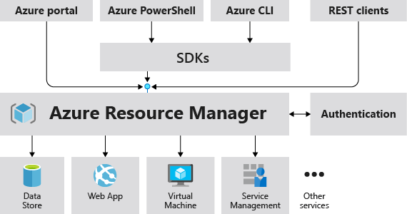

**2. Declarative Resource Management:**

* ARM uses a **declarative syntax**, allowing users to define what resources they need and how they should be configured, without the need to write complex programming code to create or modify those resources.
* The use of **Resource Manager templates** (JSON files) allows users to specify multiple resources for deployment, ensuring that all resources are created and managed as a group. This is particularly useful for deploying complex applications or solutions with multiple interconnected resources.

**3. Resource Groups and Organization:**

* ARM introduces the concept of **resource groups**, which act as containers for managing related Azure resources. All resources within a group share the same lifecycle, meaning they can be deployed, updated, or deleted together. This makes managing large-scale applications and infrastructures more efficient.
* Resource groups also provide a logical boundary for resources, and they can span different geographical locations while storing metadata in a single location. This helps ensure compliance with data residency requirements.

**4. Scalable Resource Management:**

* The flexibility of Azure Resource Manager allows businesses to scale their resources seamlessly. Users can organize resources into multiple **management groups**, **subscriptions**, and **resource groups** based on organizational needs, while also managing policies and settings at various levels.
* ARM ensures that settings defined at higher levels (e.g., management groups) are inherited by lower levels (e.g., subscriptions or resource groups), offering consistent governance and configuration across the entire cloud infrastructure.

**5. Resource Dependencies and Tagging:**

* One of the core features of ARM is the ability to define **resource dependencies**. When deploying resources, ARM ensures that dependencies are handled in the correct order (for instance, creating a virtual machine after creating its associated network resources).
* ARM also supports **tagging**, allowing resources to be organized logically within a subscription. Tags can be used for categorization, billing analysis, and cost tracking across multiple resources.

**6. Access Control and Security:**

* **Access control** in Azure is managed through Azure Resource Manager, where users can define and enforce **role-based access control (RBAC)**. This allows organizations to specify who has access to specific resources and what actions they can perform on those resources.
* ARM ensures secure management by supporting **locks** (to prevent accidental deletion or modification of critical resources) and **tags** (to better organize and group resources based on security or operational requirements).

**7. High Availability and Resiliency:**

* The Azure Resource Manager service is designed with **high availability** in mind. Its operations are distributed across multiple geographic regions, ensuring that services dependent on ARM are highly resilient.
* This resiliency ensures that Azure services that utilize ARM, such as Azure Key Vault, are robust and available across different zones and locations. However, it’s important to note that this resiliency applies only to services interacting through ARM.

**8. Resource Group Management and Customization:**

* ARM allows users to manage resources within a **resource group** based on various operational requirements. For example, if resources within a group need to be deployed or updated at different times, they can be placed in separate groups. Resources can also be moved between resource groups, enabling flexibility in organizing them according to changing needs.
* Additionally, when deleting a resource group, all resources within it are deleted automatically, ensuring that no orphaned resources are left behind.

**9. Managing Limits and Quotas:**

* Azure Resource Manager helps manage **limits** and **quotas** for resources. Some services within Azure come with adjustable limits, and users can request increases beyond the default limitations through customer support channels.
* The management of these limits ensures that users can scale their Azure resources within predefined capacities and avoid running into resource exhaustion during critical workloads.

**10. Cost Management:**

* ARM helps in managing costs by enabling businesses to apply **tags** to their resources, making it easier to track costs associated with specific departments, projects, or business units. This aids in understanding the overall billing structure and helps to optimize resource usage to avoid unnecessary costs.

**Q13) What is the difference between a General Purpose VM and a Computer Optimized VM in Azure?**

**A)**

In Microsoft Azure, **General Purpose Virtual Machines (VMs)** and **Compute Optimized Virtual Machines (VMs)** are designed for different types of workloads and have different configurations to optimize performance. Understanding the differences between these two types of VMs is crucial for selecting the right VM for specific application needs. Below is a detailed comparison between **General Purpose VMs** and **Compute Optimized VMs**:

**1. Purpose and Use Cases**

* **General Purpose VMs**: Versatile, suitable for web servers, small-to-medium databases, development/testing, and business applications with balanced CPU-to-memory ratios.
* **Compute Optimized VMs**: Designed for CPU-intensive tasks like batch processing, scientific computations, and high-performance web apps, with a focus on high CPU performance over memory.

**2. VM Configuration (CPU-to-Memory Ratio)**

* **General Purpose VMs**: Balanced 1:4 CPU-to-memory ratio, cost-effective for moderate workloads.
* **Compute Optimized VMs**: Higher 2:1 CPU-to-memory ratio, ideal for compute-heavy applications requiring more processing power than memory.

**3. Performance**

* **General Purpose VMs**: Provide balanced performance, suitable for general tasks but not optimized for heavy computation.
* **Compute Optimized VMs**: Offer better performance for tasks needing high CPU usage, such as simulations and data analysis.

**4. Cost-Effectiveness**

* **General Purpose VMs**: More cost-effective for diverse workloads with predictable resource demands.
* **Compute Optimized VMs**: More expensive due to high CPU performance but offer better price-to-performance for compute-heavy tasks.

**5. Scalability**

* **General Purpose VMs**: Suitable for scaling medium to light workloads, not ideal for extreme compute or memory needs.
* **Compute Optimized VMs**: Better for scaling CPU-heavy workloads, like simulations or large-scale computations.

**6. Example VM Types**

* **General Purpose VMs**: B-series (burstable) and D-series (balanced workloads).
* **Compute Optimized VMs**: F-series (high CPU power, suitable for compute-intensive tasks).

**7. Storage and I/O Performance**

* **General Purpose VMs**: Moderate I/O throughput, suitable for general storage needs.
* **Compute Optimized VMs**: High CPU performance, can be paired with high-performance storage for compute-intensive tasks but may not be ideal for I/O-heavy workloads.

**Summary Table:**

|  |  |  |
| --- | --- | --- |
| **Feature** | **General Purpose VMs** | **Compute Optimized VMs** |
| **Target Use Case** | Balanced workloads (e.g., web apps, small databases) | High-performance compute-heavy workloads (e.g., simulations, scientific computing) |
| **VM Series** | B-series, D-series | F-series |
| **CPU-to-Memory Ratio** | Balanced | High CPU-to-memory ratio |
| **Performance** | Good for general-purpose applications | High CPU performance for compute-heavy tasks |
| **Cost** | More cost-effective for general workloads | More expensive due to high CPU performance |
| **Scalability** | Good for moderate scaling | Excellent for scaling compute-heavy workloads |
| **Typical Use Cases** | Web servers, small databases, development/testing | Batch processing, data analysis, video rendering |